### **Comprehensive Linux Operations**

#### **Project Overview**

This project spans various aspects of Linux system administration, including file management, user and group management, service control, process handling, and more. You will be completing tasks that simulate real-world scenarios, providing hands-on experience with Linux commands and configurations.

### **Project Breakdown**

#### **Part 1: Creating and Editing Text Files (20 minutes)**

**Scenario:** You are tasked with documenting the configurations and settings for a new server. You'll use different text editors to create and update these documents.

1. **Using Nano**

Create a file server_config.txt using Nano:  
  
nano server_config.txt

Add the following content:  
  
Server Name: WebServer01

IP Address: 192.168.1.100

OS: Ubuntu 20.04

* + Save and exit (Ctrl+O, Enter, Ctrl+X).

1. **Using Vi**

Edit the same file with Vi:  
  
vi server_config.txt

Append the following text:  
  
Installed Packages: Apache, MySQL, PHP

* + Save and exit (Esc, :wq).

1. **Using Vim**

Further edit the file with Vim:  
  
vim server_config.txt

Add the following text:  
  
Configuration Complete: Yes

* + Save and exit (Esc, :wq).

#### **Part 2: User & Group Management (20 minutes)**

**Scenario:** You need to set up user accounts and groups for a new team joining the project.

1. **Adding/Removing Users**

**Add a new user developer:**  
  
sudo adduser developer

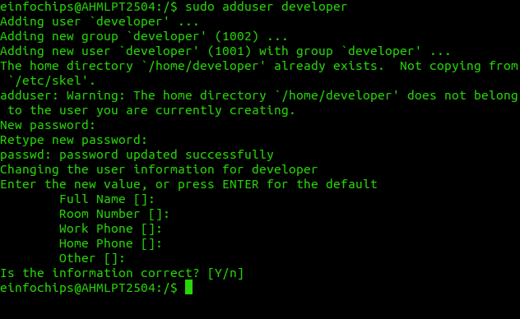

**Remove the user developer:**  
  
sudo deluser developer

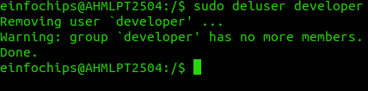

1. **Managing Groups**

**Create a group devteam:**  
  
sudo groupadd devteam

**Add the user developer to the devteam group:**  
  
sudo usermod -aG devteam developer



**Remove the user developer from the devteam group:**  
  
sudo gpasswd -d developer devteam



#### **Part 3: File Permissions Management (20 minutes)**

**Scenario:** Ensure that only the appropriate users have access to specific files and directories.

1. **Understanding File Permissions**

View permissions for server_config.txt:  
  
ls -l server_config.txt



* + Discuss the output (e.g., -rw-r--r--).

1. **Changing Permissions and Ownership**

Change permissions to read/write for the owner and read-only for others:  
  
chmod 644 server_config.txt



Verify the change:  
  
ls -l server_config.txt



Change the owner to developer and the group to devteam:  
  
sudo chown developer:devteam server_config.txt

Verify the change:  
  
ls -l server_config.txt

#### **Part 4: Controlling Services and Daemons (20 minutes)**

**Scenario:** Manage the web server service to ensure it is running correctly and starts on boot.

1. **Managing Services with systemctl**

Start the Apache service:  
  
sudo systemctl start apache2

Stop the Apache service:  
  
sudo systemctl stop apache2

Enable the Apache service to start on boot:  
  
sudo systemctl enable apache2

Disable the Apache service:  
  
sudo systemctl disable apache2

Check the status of the Apache service:  
  
sudo systemctl status apache2

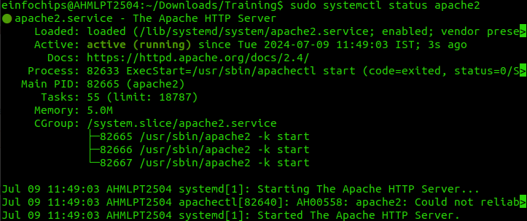

1. **Understanding Daemons**
   * Discuss the role of the sshd daemon in providing SSH access to the server.

#### **Part 5: Process Handling (20 minutes)**

**Scenario:** Monitor and manage processes to ensure the server is performing optimally.

1. **Viewing Processes**

List all running processes:  
  
ps aux

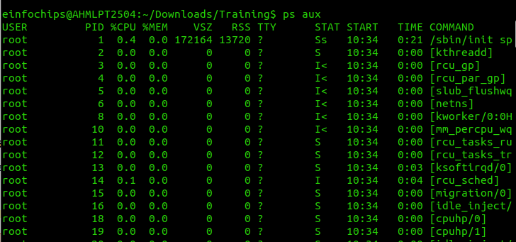

Use top to view processes in real-time:  
  
top

1. **Managing Processes**

Identify a process to kill using ps or top, then kill it:  
  
kill <PID>

Change the priority of a process (e.g., running sleep with a lower priority):  
  
nice -n 10 sleep 100 &

Change the priority of the process using renice:  
  
renice +10 <PID>

### **Creating and Deploying a Static Website with Apache2**

#### **Preparation (5 minutes)**

* Ensure you have access to a Linux environment (e.g., virtual machines, EC2 instances, or local installations) with sudo privileges.

### **Activity Breakdown**

#### **Part 1: Installing Apache2 (5 minutes)**

1. **Update Package Lists**

Open the terminal and run:  
  
sudo apt update

1. **Install Apache2**

Install Apache2 by running:  
  
sudo apt install apache2

1. **Start and Enable Apache2**

Start the Apache2 service:  
  
sudo systemctl start apache2

Enable Apache2 to start on boot:  
  
sudo systemctl enable apache2

1. **Verify Installation**
   * Open a web browser and navigate to http://your_server_ip. You should see the Apache2 default page.

#### **Part 2: Creating the Website (10 minutes)**

1. **Navigate to the Web Directory**

Change to the web root directory:  
  
cd /var/www/html

1. **Create a New Directory for the Website**

Create a directory named mystaticwebsite:  
  
sudo mkdir mystaticwebsite

Change ownership of the directory:  
  
sudo chown -R $USER:$USER /var/www/html/mystaticwebsite

1. **Create HTML File**

Create and edit the index.html file:  
  
nano /var/www/html/mystaticwebsite/index.html

Add the following content:  
  
<!DOCTYPE html>

<html>

<head>

<title>My Static Website</title>

<link rel="stylesheet" type="text/css" href="styles.css">

</head>

<body>

<h1>Welcome to My Static Website</h1>

<p>This is a simple static website using Apache2.</p>

<script src="script.js"></script>

</body>

</html>

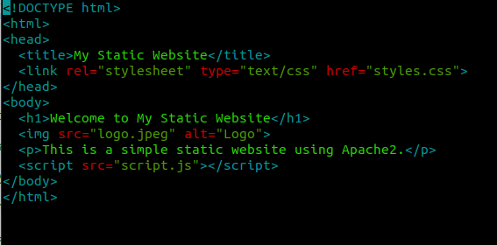

* + Save and exit (Ctrl+O, Enter, Ctrl+X).

1. **Create CSS File**

Create and edit the styles.css file:  
  
nano /var/www/html/mystaticwebsite/styles.css

Add the following content:  
  
body {

font-family: Arial, sans-serif;

background-color: #f0f0f0;

text-align: center;

margin: 0;

padding: 20px;

}

h1 {

color: #333;

}

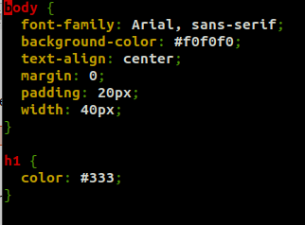

* + Save and exit (Ctrl+O, Enter, Ctrl+X).

1. **Create JavaScript File**

Create and edit the script.js file:  
  
nano /var/www/html/mystaticwebsite/script.js

Add the following content:  
  
document.addEventListener('DOMContentLoaded', function() {

console.log('Hello, World!');

});



* + Save and exit (Ctrl+O, Enter, Ctrl+X).

1. **Add an Image**

Download or copy an image file (e.g., logo.png) to the website directory:  
  
cp /path/to/your/logo.png /var/www/html/mystaticwebsite/logo.png

Update index.html to include the image:  
  
<body>

<h1>Welcome to My Static Website</h1>

<img src="logo.png" alt="Logo">

<p>This is a simple static website using Apache2.</p>

<script src="script.js"></script>

</body>



#### **Part 3: Configuring Apache2 to Serve the Website (10 minutes)**

1. **Create a Virtual Host File**

Create and edit the virtual host configuration file:  
  
sudo nano /etc/apache2/sites-available/mystaticwebsite.conf

Add the following content:  
  
<VirtualHost *:80>

ServerAdmin webmaster@localhost

DocumentRoot /var/www/html/mystaticwebsite

ErrorLog ${APACHE_LOG_DIR}/error.log

CustomLog ${APACHE_LOG_DIR}/access.log combined

</VirtualHost>

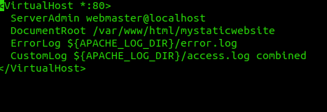

* + Save and exit (Ctrl+O, Enter, Ctrl+X).

1. **Enable the New Virtual Host**

Enable the virtual host configuration:  
  
sudo a2ensite mystaticwebsite.conf

1. **Disable the Default Site**

Disable the default site configuration:  
  
sudo a2dissite 000-default.conf

1. **Reload Apache2**

Reload the Apache2 service to apply the changes:  
  
sudo systemctl reload apache2

1. **Test the Configuration**
   * Open a web browser and navigate to http://your_server_ip. You should see the static website with the HTML, CSS, JS, and image.

